1. What is SDLC  
     
   SDLC is a step by step process to develop any software with high quality, within the budget and in shortest possible time.  
     
   timeline + budget + quality = SDLC  
     
   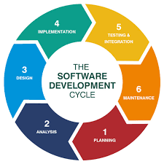

2) What is software testing?

Process to verify and validate the developed software.

Software Testing is the process of checking that a software program works as expected  
free of bugs before release.  
  
3) What is agile methodology?  
  
Able to move quickly and easily.  
  
It is iterative, incremental, flexible, collaborative, and adjustable.  
  
Agile methodology shortens project timelines by delivering working software in incremental releases, reducing the risk of long development cycles.

4) What is SRS  
A software requirements specification is a description of a software system to be developed. It is modeled after the business requirements specification.

5) What is oops

Object-Oriented Programming System (OOP) is a way of organizing code by grouping data and functions (actions) into "objects", which can then interact with each other.

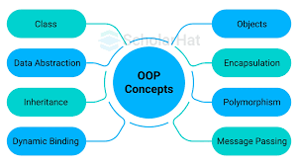

6) Write Basic Concepts of oops

Object-oriented programming aims to implement real-world entities like inheritance, hiding, polymorphism, etc in programming.

An object is a component of a program that knows how to perform certain actions and how to interact with other elements of the program. Objects are the basic units of object-oriented programming.

A simple example of an object would be a person. Logically, you would expect a person to have a name.  
  
7) What is object  
  
In Object-Oriented Programming (OOP), an object is an instance of a class that combines data (attributes) and methods (functions) into a single entity.

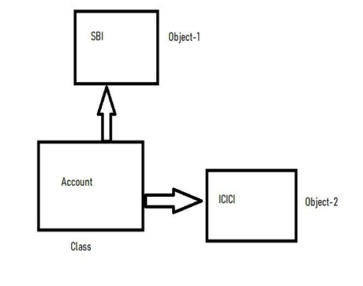  
  
8) What is class

In **Object-Oriented Programming (OOP)**, a **class** is a blueprint or template used to create objects. It defines the **attributes** (data) and **methods** (functions) that the objects created from the class will have.

9) What is encapsulation

Encapsulation is **a programming concept that bundles data and methods into a single unit**

Encapsulation is one of the core principles of Object-Oriented Programming (OOP). It refers to the practice of restricting direct access to certain parts of an object and controlling how the data is accessed or modified.

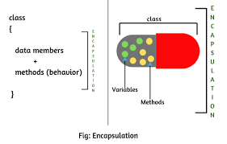

10) What is inheritance  
  
Inheritance is an Object-Oriented Programming (OOP) concept where a new class (child/subclass) derives the properties and behaviors of an existing class (parent/superclass).

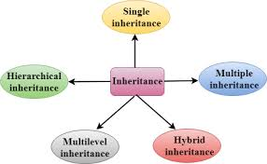

11) What is polymorphism

In object-oriented programming (OOP), polymorphism means "many forms" and allows objects of different classes to be treated as objects of a common type, enabling flexible and reusable code.

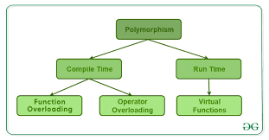

12) Draw Usecase on online bill payment system (paytm)  
  
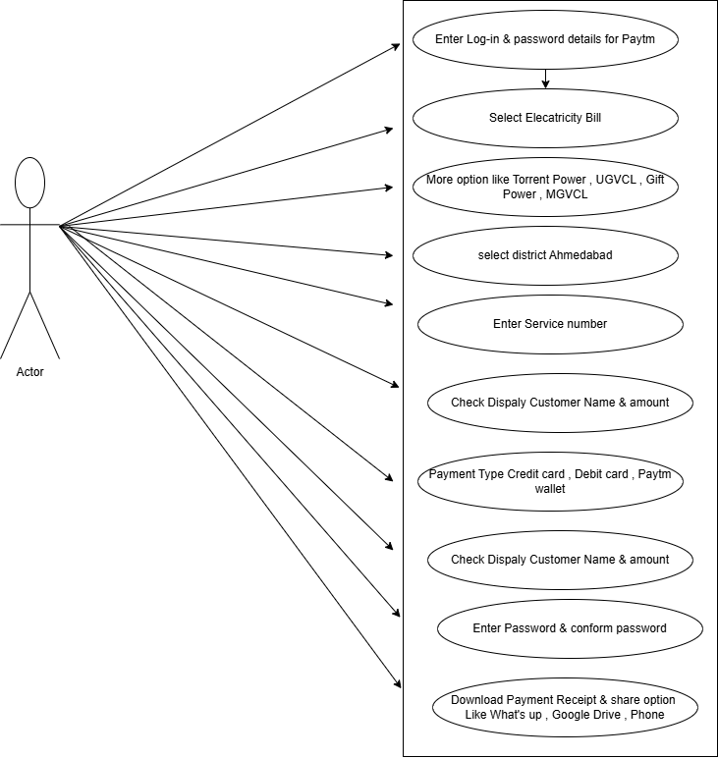

13) Draw Usecase on banking system for customers.

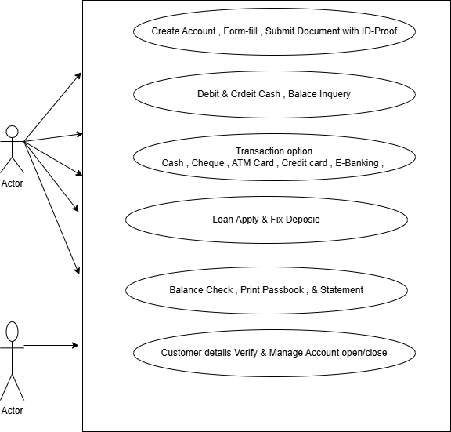

14) Draw Usecase on Broadcasting System.  
  
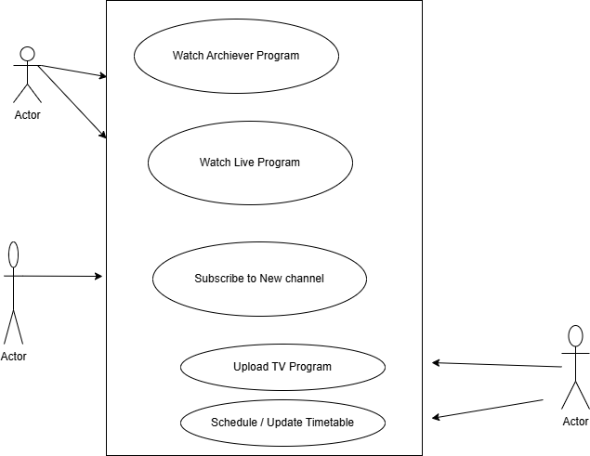

15) Write SDLC phases with basic introduction

1)) Planning / Requirement Gathering (What)

Problems can be arised while gathering the req. :

----------------------------------------------

- lack of clarity :

- req. confusion : functional vs. non-functional

- req. amalgamation (together) :

2)) Analysis (How)

Prepare the SRS : System/software requirement specification.

A software requirements specification (SRS) is a complete description

of the behavior of the system to be developed.

Types of Requirements:

-------------------------------

-customer req

-functional req.

-nonfunctional req.

3)) Designing : (view the system - prototype)

multiple designs for the product architecture are present in the Design Document Specification (DDS)

4)) Implementation / building /coding (h/w, s/w)

The actual coding of the software takes place in this phase

5)) Testing (QA)

The developed software is tested for bugs and defects.

6)) Maintenance

the software is monitored and updated based on user feedback.

After retrieving beneficial feedback, the company releases it as it is or with auxiliary improvements to make it further helpful for the customers.

16) Explain Phases of the waterfall model

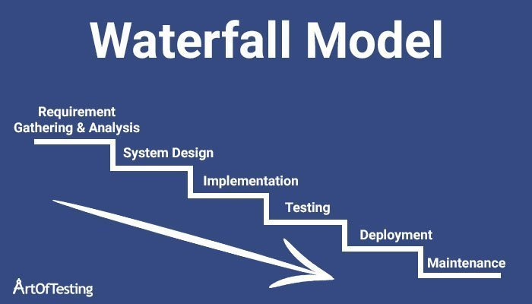

17) Write phases of spiral model

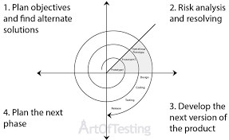

20) Draw usecase on OTT Platform.

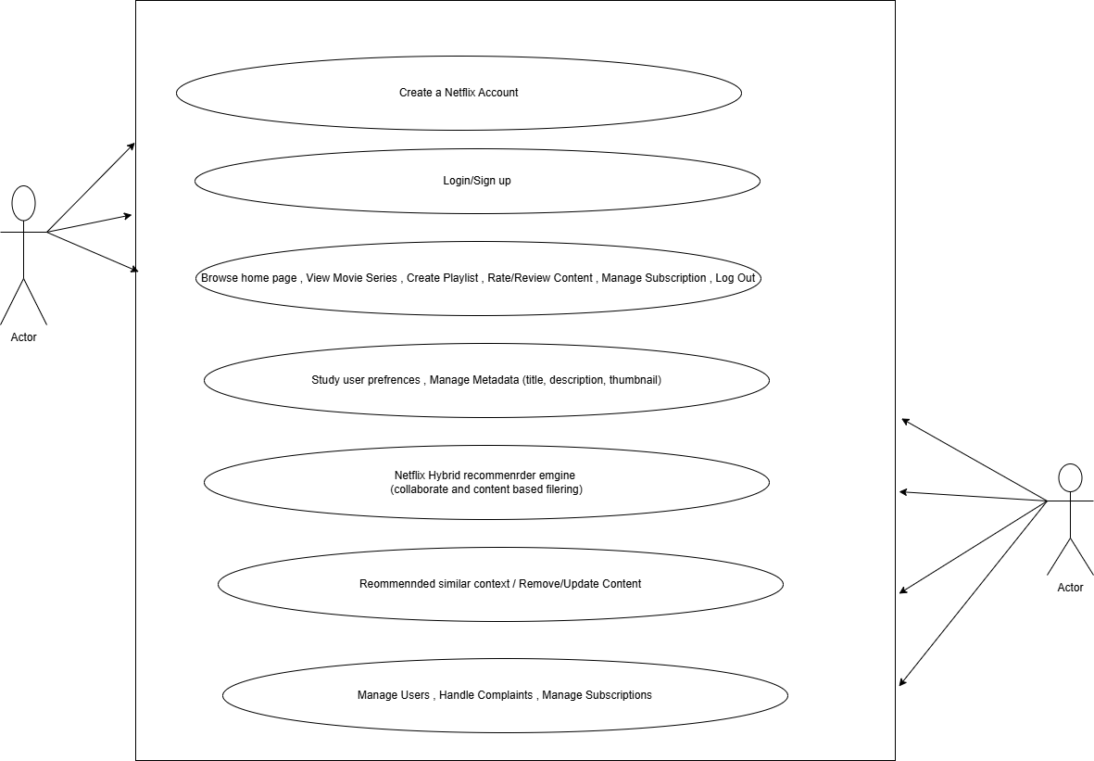

21) Draw usecase on E-commerce application

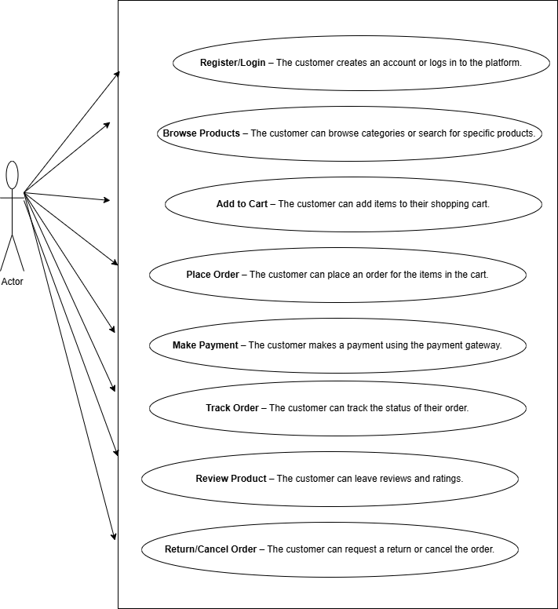

22) Draw usecase on Online shopping product using payment gateway.

